FILE SHARING PLATFORM: Teferi Shiferaw
The File Sharing platform performs a comprehensive solution for users to upload, manage, and share files. It includes features for space management, file organization, and user collaboration, of course, all while maintaining security through user authentication and controlled sharing mechanisms. The file sharing platform is built with modern web technologies, likely using a (React -frontend) with a backend that integrates with (Appwrite-cloud-based) for storage and database operations. This is just to give some highlight, I will prepare a detailed user guide and/or user manual.
An overview of the File Sharing platform and its functionalities:
Pictorial representation at glance: first the users have the option to 1-sign-up or sign-in and then 2- OTP message will be sent to their e-mail address please go through the pictures as follow: mind you I will replace The log”StoreIt” with the any utility logo, after all it’s a “figma” design
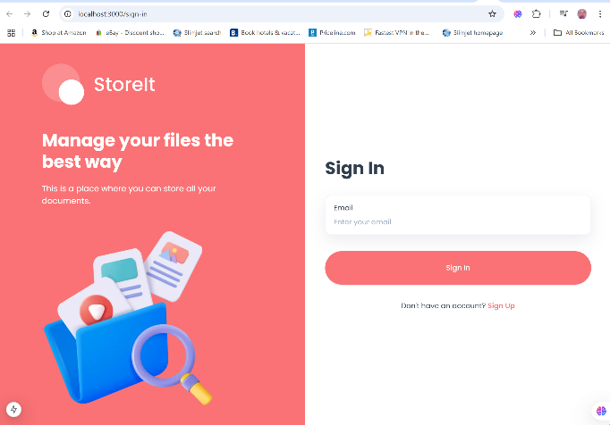
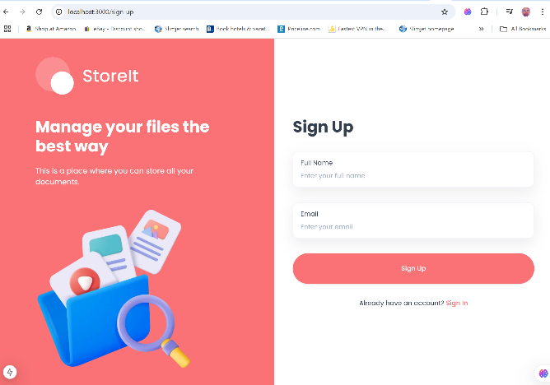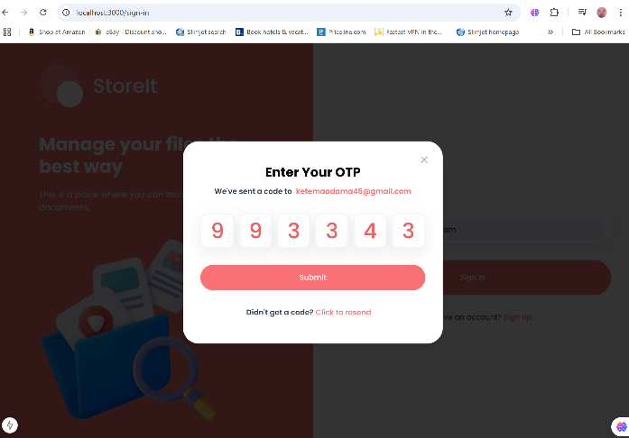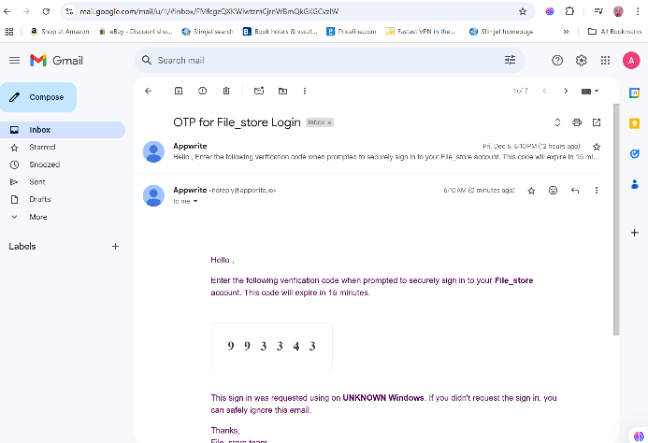

After the user is successfully signed in the following user-interface will be shown. For example a user called Adamas Ketema Dada is shown to left-bottom corner of the dashboard with his google e-mail.
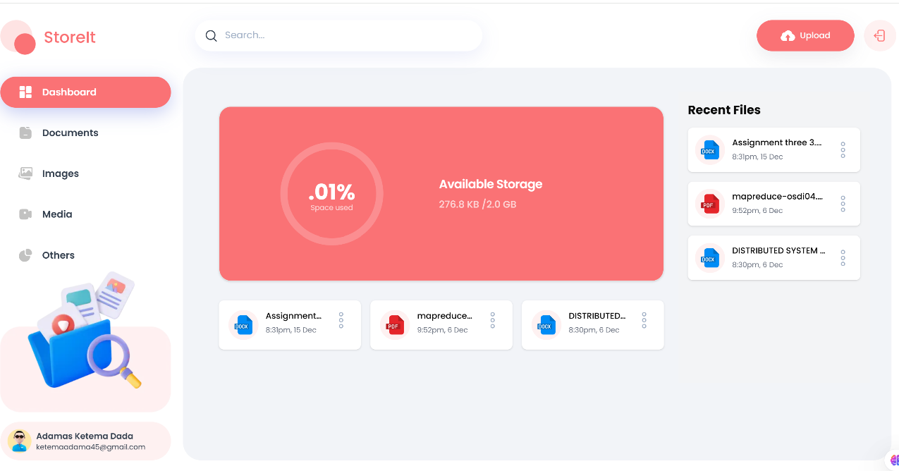
Have you seen the other functionalities which is similar to youtube! Ahha! You can rename, see file details, share, download, and Delete all in one click! The files in center are previously uploaded ones OK!
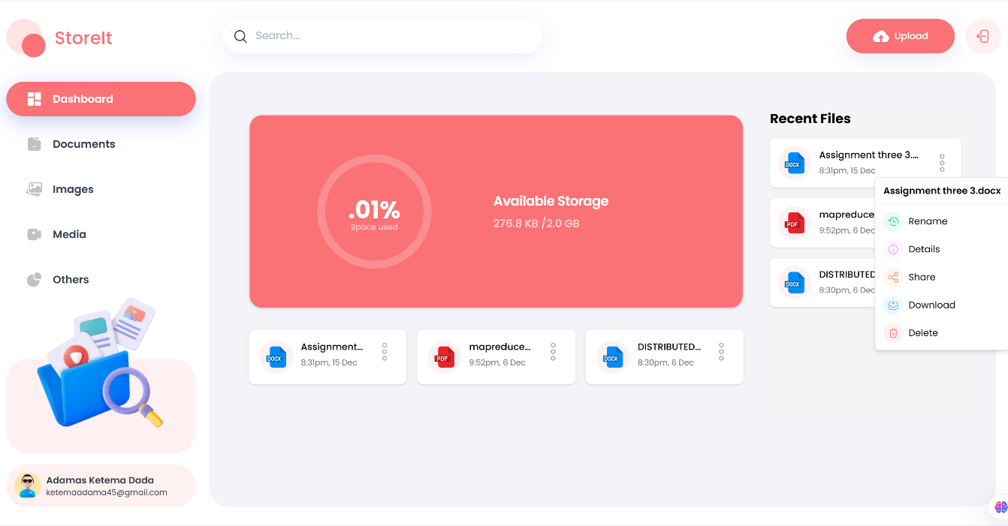
………Now even the same functionality, on previously uploaded files can be applied… Ahaa! Trust me this might seem easy task. No its not! More than 3000 line of code have been written.
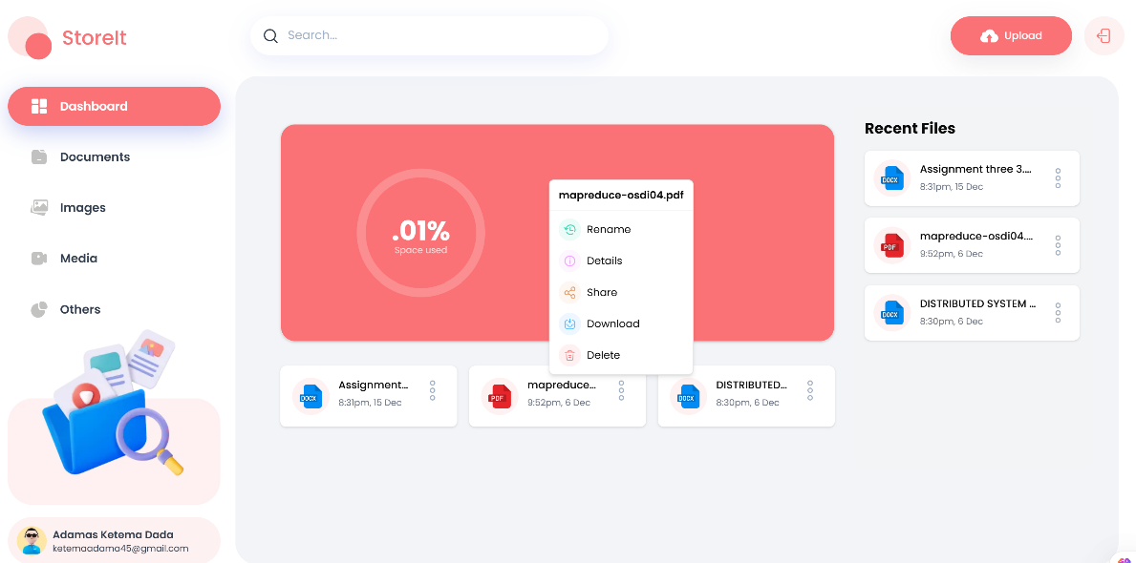
Have you noticed the difference a user clicked Documents …please don’t say so what! Look at the search and sorting functionality…user can sort from newest to oldest…A to Z…perfection and cleanness! Do you want search…Of course!
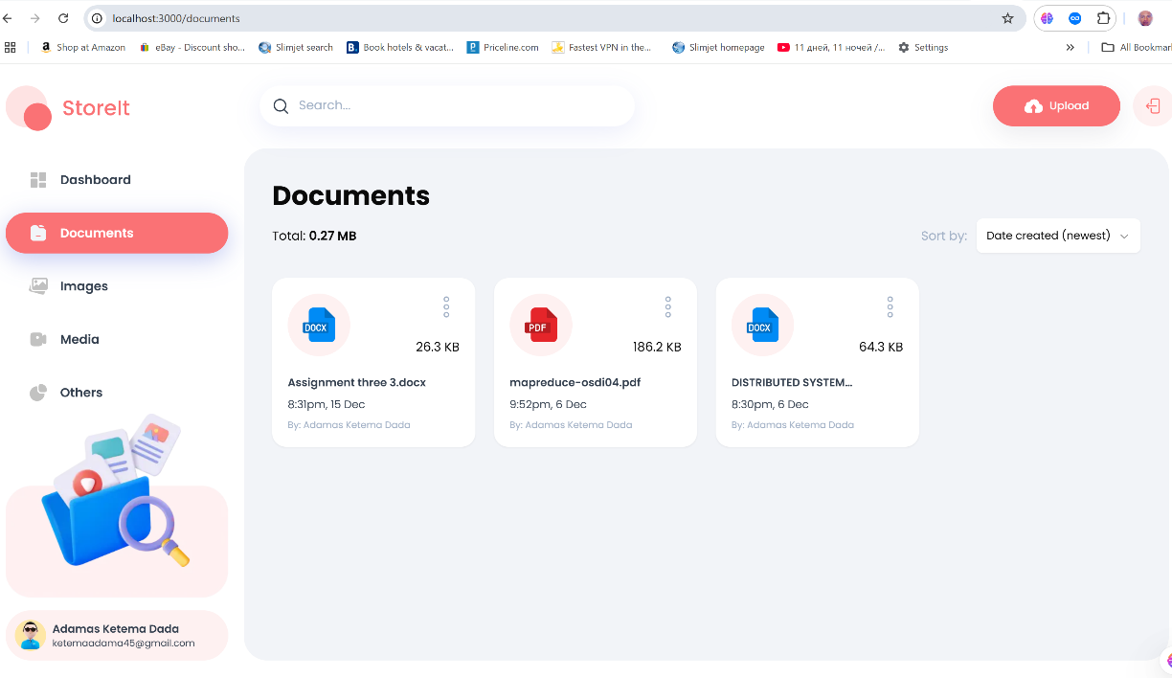

You can even find the same functionality at your fingertips buddy! Have a look at the picture below. Please!
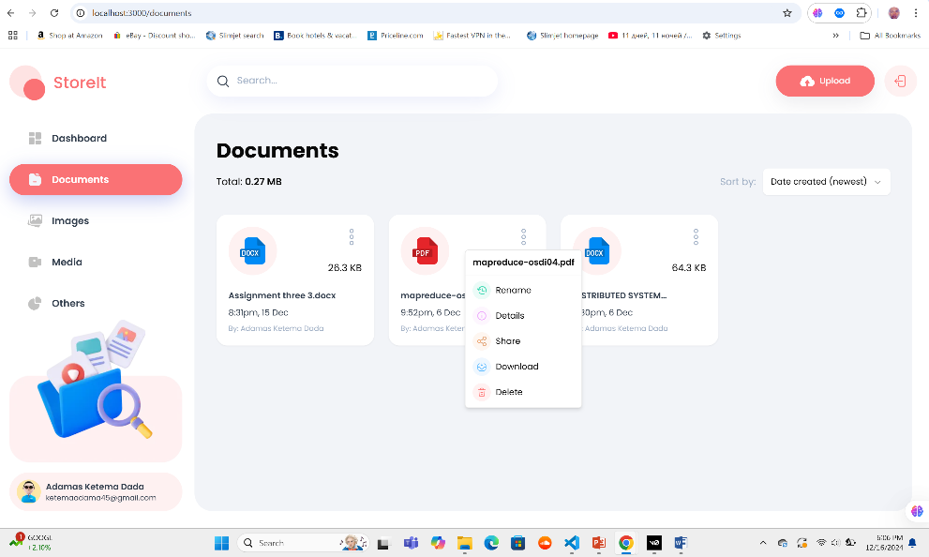
- File Management:
The platform allows users to upload, download, rename, share, and delete files. It supports various file types, including documents, images, videos, and audio files.
- User Authentication:
The system implements user authentication using OTP structure a much secured way of handling user authentication.
- Storage Integration:
The platform integrates with a storage solution, likely Appwrite which is a cloud-based database, its versatile we can use other cloud-based database handlers too.
- File Metadata:
Files are associated with metadata such as name, size, type, and creation/update timestamps.
- Sharing Capabilities:
Users can share files with others, by email.
- Space Management:
The platform tracks and manages storage space usage for each user, categorizing it by file types (image, document, and video, audio which are media files, and others).
- File Upload Interface:
There's a dedicated `FileUploader` component that handles file uploads with features like drag-and-drop and multiple file selection.
- Search and Sorting:
The platform supports searching for files and sorting them based on various criteria.
- File Type Detection:
The system can detect and categorize file types based on their extensions.
- Dashboard:
There's a dashboard feature that likely displays an overview of the user's files and storage usage.
- Environment Variable Usage:
The platform uses environment variables for configuration, suggesting it's designed to be deployable in different environments.
- Error Handling:
The code includes error handling mechanisms to manage and report issues during file operations.
- Server-Side Operations:
Many file operations are performed server-side, by the use of server actions and database operations.
- Client-Side Components:
The platform includes client-side React components for user interaction, such as the file uploader.

